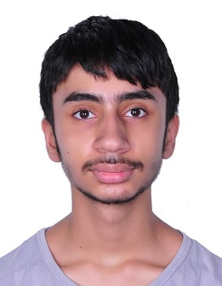

**Personal Info:**

**Name**

Ebrahim Abbas Habib

**Address**

Bahrain,

Jidhafs Manama

**Phone**

+973 36380313

**Email**

[Ebrahimabass2016@gmail.com](mailto:Ebrahimabass2016@gmail.com)

**Language Skills**

* Arabic
* A bit of English

**EDUCATION :**

Graduated

Naim Secondary Boys School

Currently pursuing:

University of Bahrain, Bachelor in Business

**WORK EXPERIEANCE :**

* Customer service in small bakery

**DECLARATION :**

I do hereby declare that the above information is true to the best of my knowledge.

**ADDITONAL SKILLS :**

* Hard worker.
* Quick learner.
* self-motivated

**Curriculum Vitae**